**Random Variables**

**A random variable is a variable whose possible values are numerical outcomes of a random phenomenon**

**Example:**

**Rolling Of a Die**

**X = {1,2,3,4,5,6}**

**Coin Tossed**

**Sample Space S = {H, T}**

**C = outcome when we toss a coin**

**X = number of heads when we toss a coin**

**X= {1,0}**

**Notation**

**It is conventional to denote the random variable by a capital letter and the possible values it can take by a small letter.**

**Examples:**

**Let X = number of heads when we toss a coin, then x ∈ {0, 1}**

**Let Z = weight of a randomly selected student in this class, then z ∈ (0, ∞)**

**z ∈ (0, ∞) Zero is not included**

**z ∈ [0, ∞] zero is included**

**Random Variable: Another Perspective**

**A sample space is the set of all possible outcomes of an experiment.**

**A random variable is a rule for associating a number with each element in a sample space.**

So, if w is an element of the sample space **S** (i.e., w is one of the possible outcomes of the experiment concerned) and the number x is associated with this outcome, then **X(w) = x.**

**Example:**

**Experiment:**

**What we DO in School Days**

**F(x)=2x**

**F (2) = 2 x 2 = 4**

Tossing a coin Sample space: **S = {H, T}.**

X is the number of heads when we toss a coin.

Then, **X(H) = 1** and **X(T) = 0**.

**Example**

Suppose there are 8 balls in a bag. The random variable X is the weight, in kg, of a ball selected at random. Balls 1, 2 and 3 weigh 0.1kg, balls 4 and 5 weigh 0.15kg and balls 6, 7 and 8 weigh 0.2kg.

**Experiment**: Selecting a ball at random Sample Space: S = {1, 2, 3, 4, 5, 6, 7, 8}

X is weight of a ball selected at random **Then,**

**X(1) = 0.1, X(2) = 0.1, X(3) = 0.1,**

**X(4) = 0.15, X(5) = 0.15,**

**X(6) = 0.2, X(7) = 0.2, X(8) = 0.2**

**Types of Random Variables**

**Discrete Random Variables**

● Countable

● Discrete Points

● E.g. X = number that comes when you roll a dice,

i.e. X ∈ {1,2,3,4,5,6}

**Continuous Random Variables**

● Uncountable

● Continuous Intervals

● E.g. X = height of a randomly chosen student in this class

**Probability Distribution**

**Example**

Suppose there are 8 balls in a bag. The random variable X is the weight, in kg, of a ball selected at random. Balls 1, 2 and 3 weigh 0.1kg, balls 4 and 5 weigh 0.15kg and balls 6, 7 and 8 weigh 0.2kg.

**Experiment**: Selecting a ball at random Sample Space: S = {1, 2, 3, 4, 5, 6, 7, 8}

X is weight of a ball selected at random **Then,**

**X(1) = 0.1, X(2) = 0.1, X(3) = 0.1,**

**X(4) = 0.15, X(5) = 0.15,**

**X(6) = 0.2, X(7) = 0.2, X(8) = 0.2**

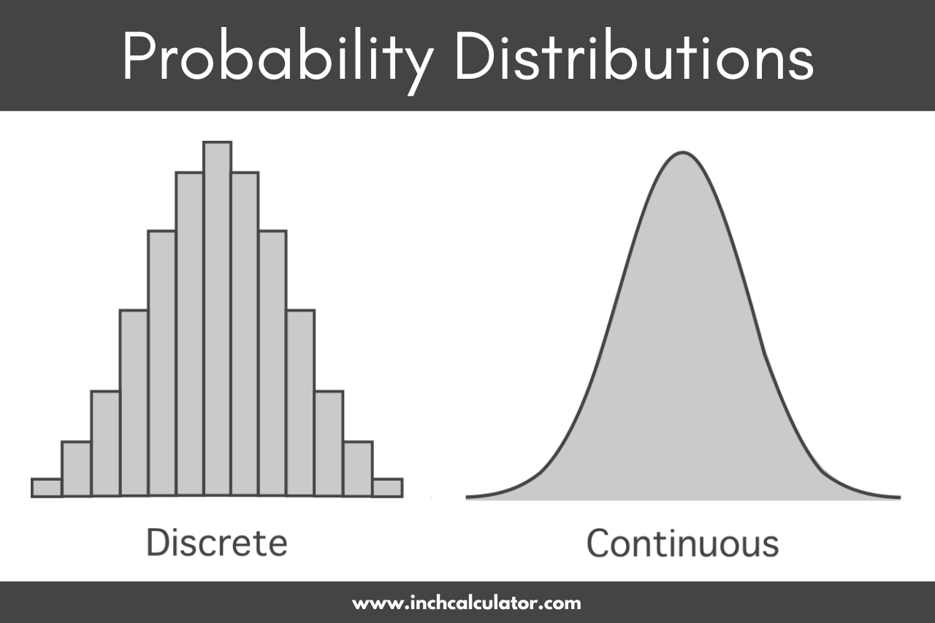

**Cumulative Distribution Function**

**Probability till That Point:**

**The cumulative distribution function (CDF) of X is FX(x) = P (X ≤ x).**

**It gives the probability that X assumes a value that does not exceed x.**

**CDFs are also known as “Distribution functions (DF)”**

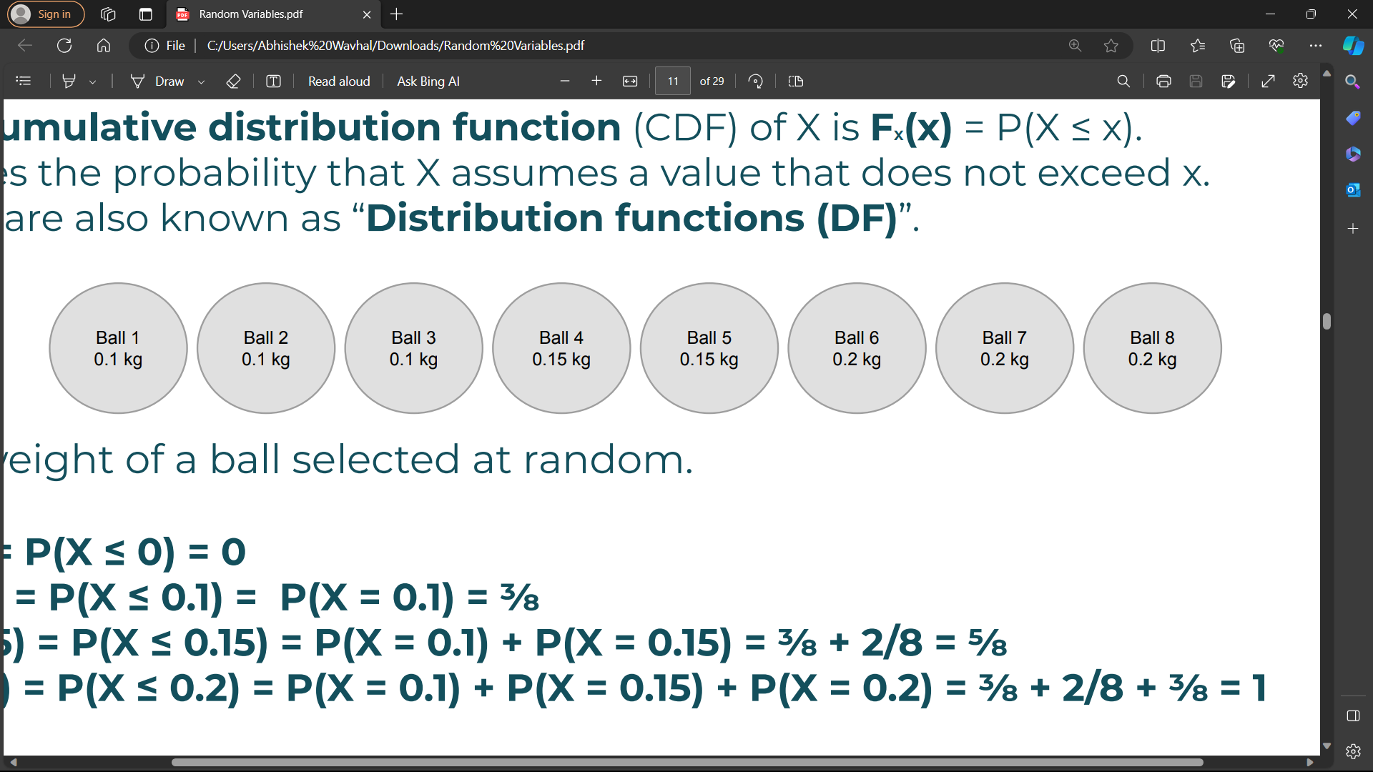

**X is weight of a ball selected at random.**

**FX(0) = P(X ≤ 0) = 0**

**FX(0.1) = P(X ≤ 0.1) = P(X = 0.1) = ⅜**

**FX(0.15) = P(X ≤ 0.15) = P(X = 0.1) + P(X = 0.15) = ⅜ + 2/8 = ⅝**

**FX(0.2) = P(X ≤ 0.2) = P(X = 0.1) + P(X = 0.15) + P(X = 0.2) = ⅜ + 2/8 + ⅜ = 8/8 = 1**